

Write About Yourself

**Your GEAR UP Coordinator**

**GEAR UP Objectives**

1. **Increase students’ academic performance and preparation for postsecondary education.**

2. **Increase high school graduation and postsecondary participation rates.**

3. **Increase students’ and their families’ knowledge of postsecondary options, preparation, and finances.**

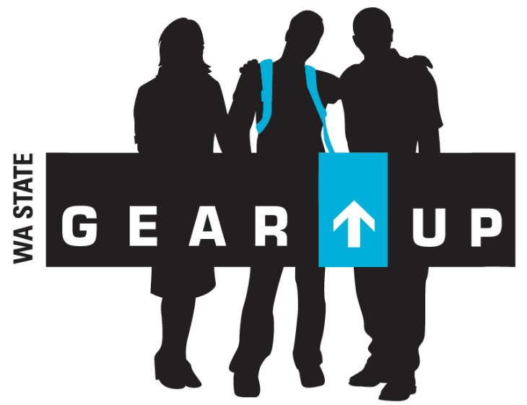

**Name of School**

**GEAR UP**

**My Dream, My Plan.**

*Supporting every student in making their aspirations a reality.*

**Contact Information**

Name

Email

Phone Number

Let us help you start planning for your child’s future.

Get involved today!

What is postsecondary education? There are many options, including:

• Apprenticeships

• Military

• On-the-job training programs

• Community college certificates

• Two-year degrees

• Four-year degrees

GEAR UP supports students in preparing for the postsecondary education pathway that they choose.

**What We Mean**

Insert School Logo

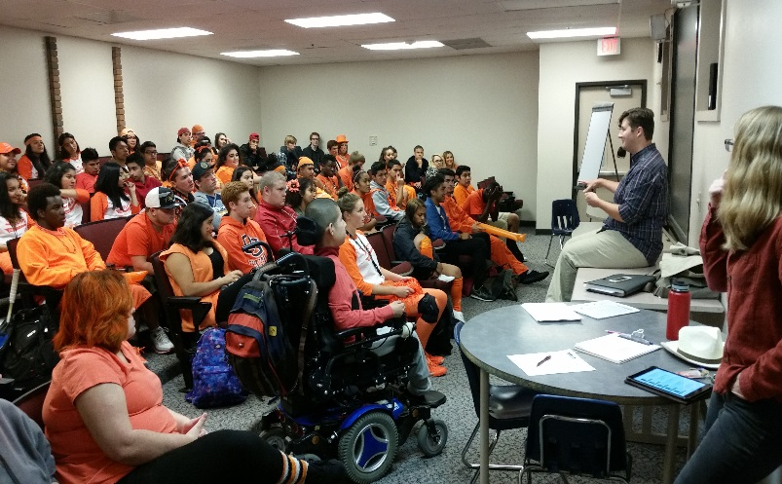

**GEAR UP is FREE!**

* Campus Visits
* Career Exploration Activities
* Financial Aid Counseling/Advising
* Academic Support
* Academic Planning
* Career Counseling
* Mentoring
* Educational Field Trips
* SAT/ACT Test Preparation
* Summer Programs
* AP/Honor Classes Support

GEAR UP knows that most careers require a postsecondary credential (research says 68% of all jobs!). We are here to help you and your child prepare for whatever path they choose. GEAR UP offers the following services to families:

* Financial Aid & Scholarship Workshops & Assistance
* Academic, social, and emotional preparation and support.
* GEAR UP Family Nights
* Campus Visits
* Parent/Teacher/Student Conferences
* College Application Assistance
* Pre-College Assessment Support

Research shows family engagement leads to:

* Greater student achievement.
* Higher grades and test scores.
* Better attendance.
* Higher graduation rate.
* Greater enrollment rates in education after high school.
* Decrease in behaviors such as alcohol use, violence, and antisocial behavior.
* Better transitions, quality of work, and realistic post-high school plans.

**Benefits of Family Engagement Engagement**

**Student Services**

**GEAR UP is a federal grant program designed to increase the number of students who are prepared to enter and succeed in education after high school.**

**Washington State GEAR UP will prepare students for earning a postsecondary credential that has labor market value.**

**Program Overview**

**Family Services**